**Assignment 2: Simple Serverless Application**

**Tasks:**

1. **Frontend:**
   * Create a simple “Hello World” HTML/CSS web page
   * Host it on S3 as a static website
   * Enable public access for website hosting

**Bucket Created in S3:**

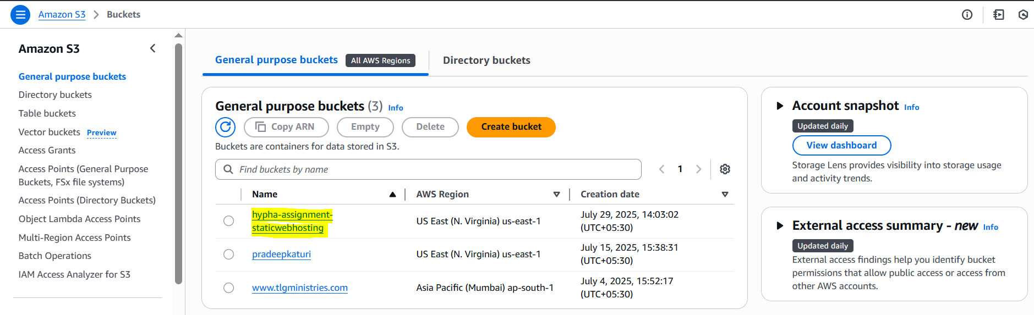

**Uploaded index.html to the Bucket:**

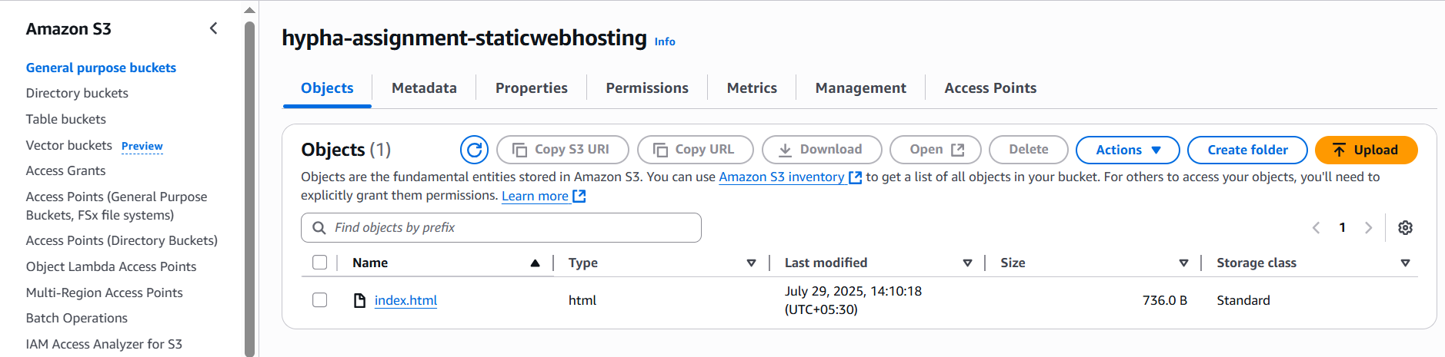

**Enabled Static Website Hosting under Bucket Properties:**

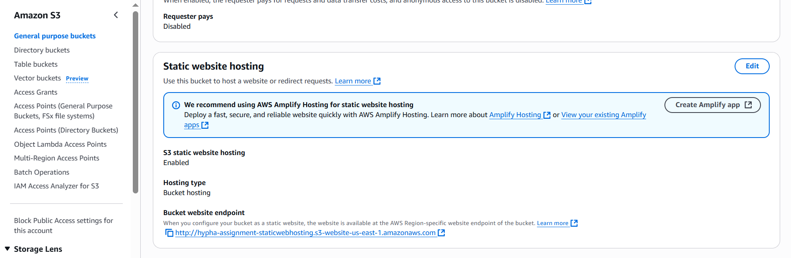

**Updated Bucket Policy to Allow anyone to Get the Objects in the Bucket**

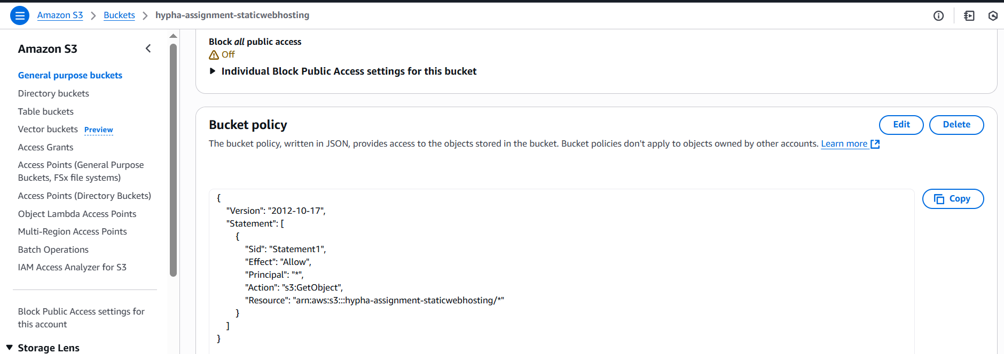

**Able to access the website or static content uploaded in S3 with the** **Bucket website endpoint: http://hypha-assignment-staticwebhosting.s3-website-us-east-1.amazonaws.com**

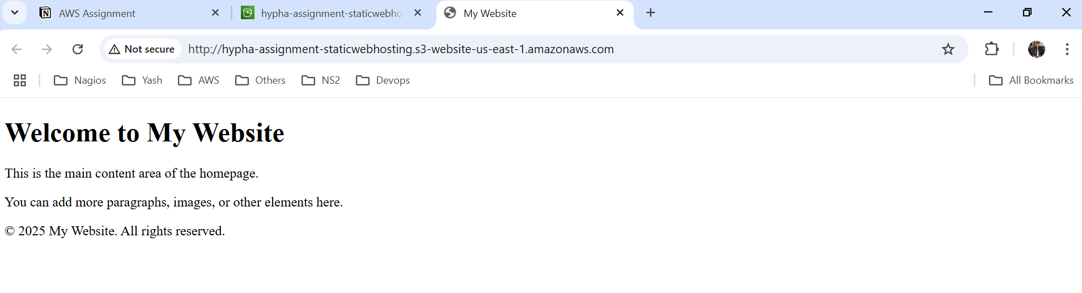

**Sample DynamoDB Table:**

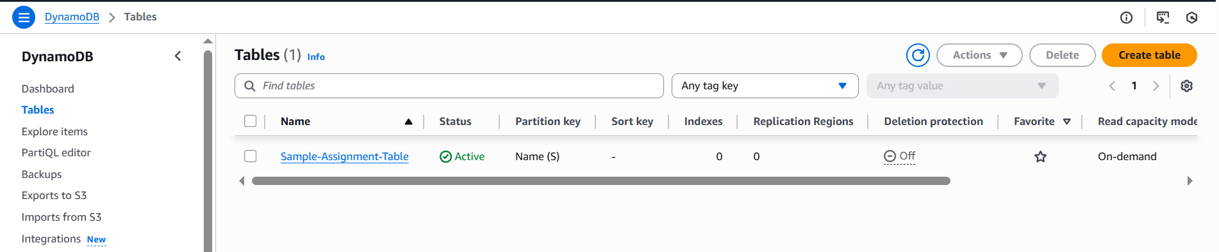

**Lambda Functions to Retrieve Store Data and Store DynamoDB Table:**

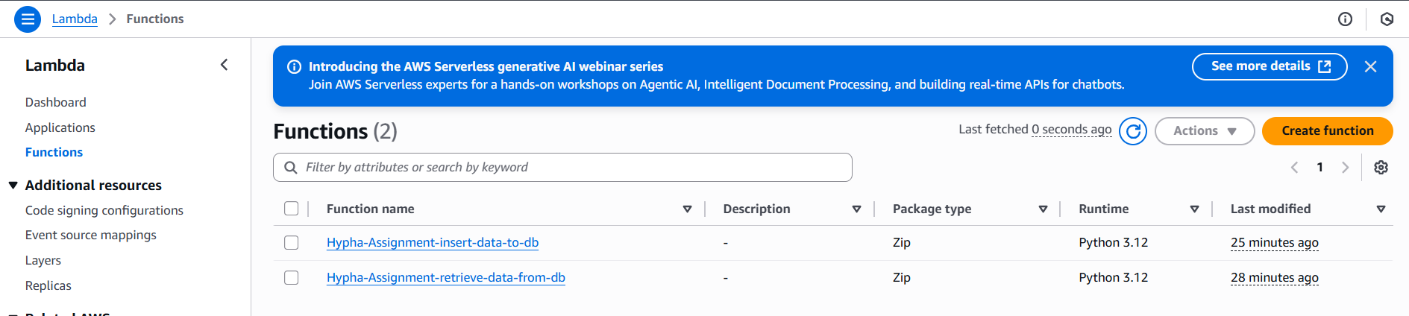

**Lambda Function to Insert Data into DynamoDB Tale:**

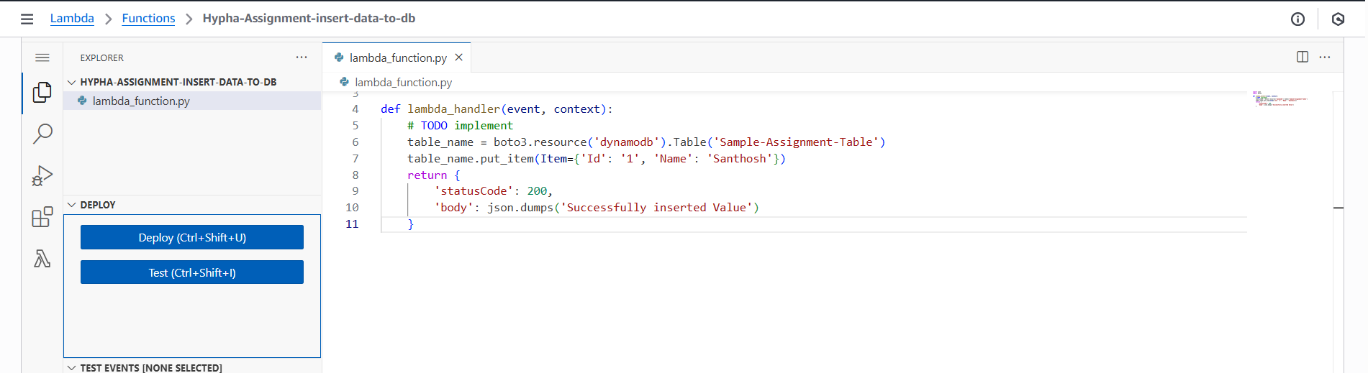

**Lambda Function to Retrieve Data from DynamoDB Table:**

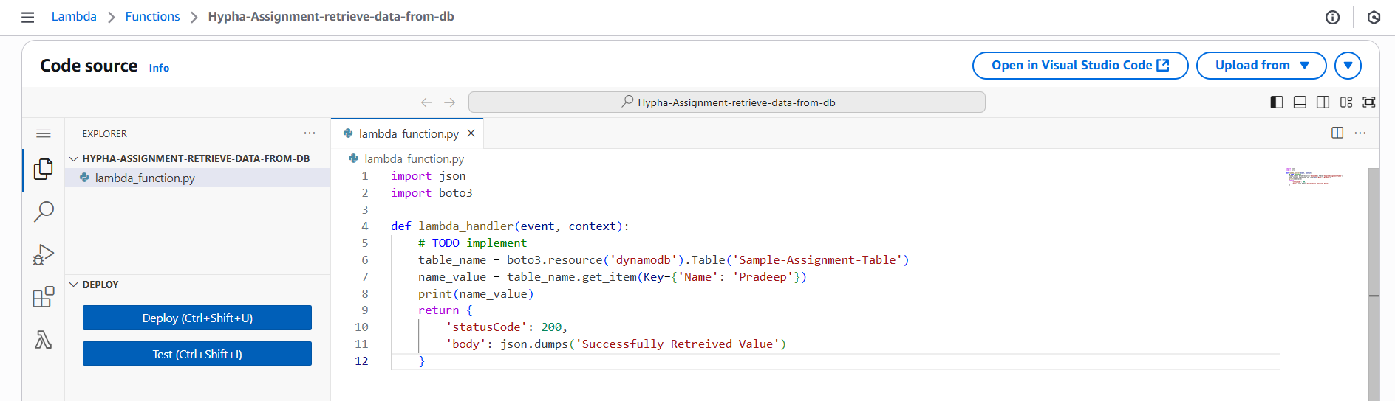

**Two API’s with GET and POST Method:**

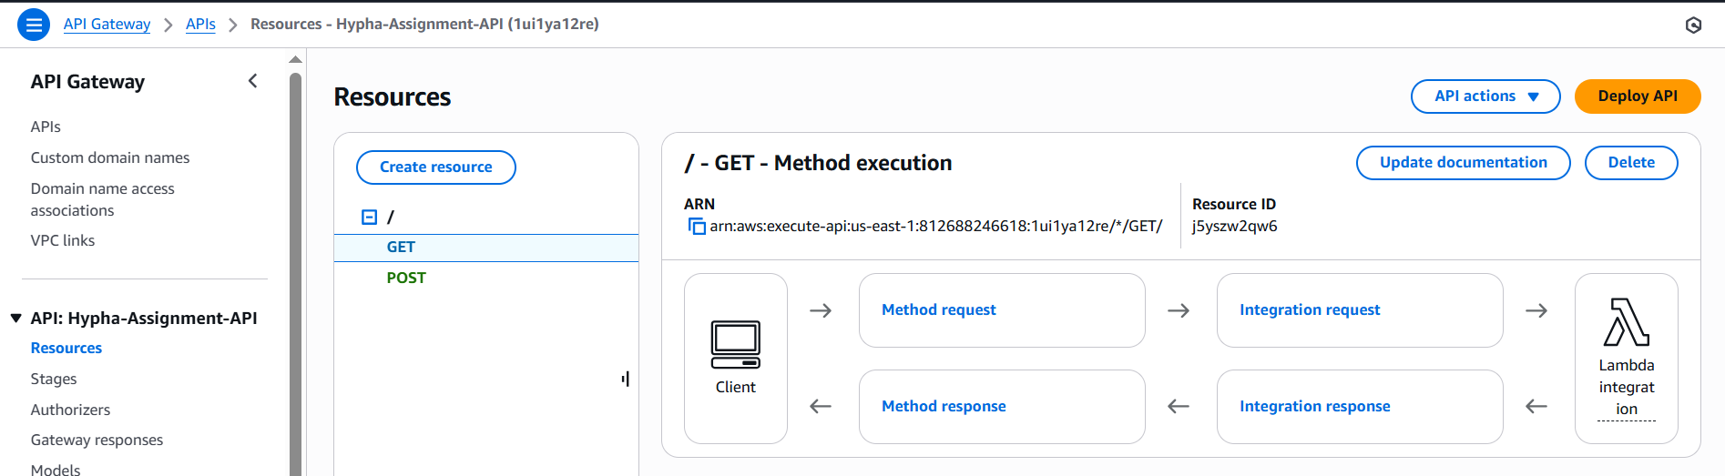

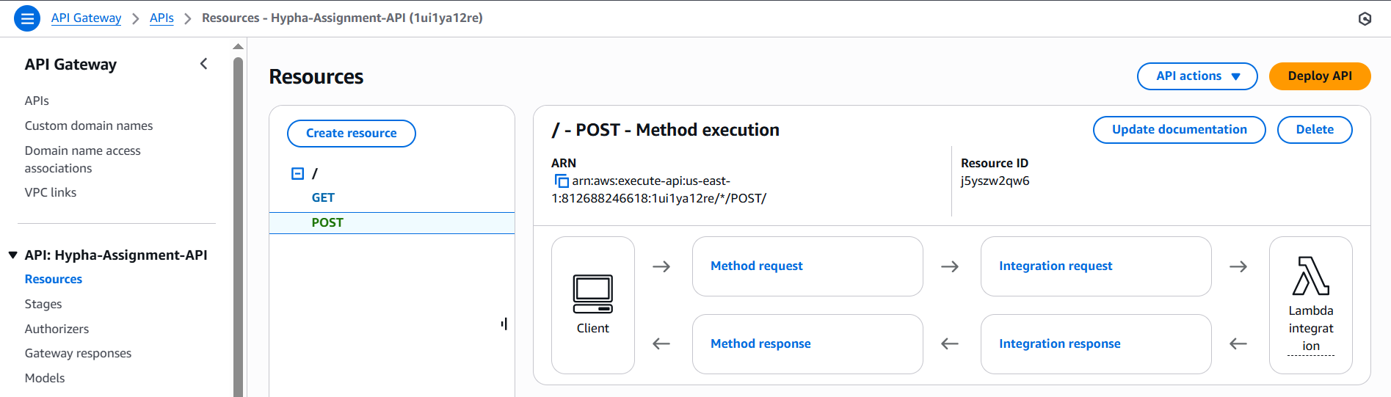

**Monitoring Lambda Functions using CloudWatch:**

